**BLOCKCHAIN INTEGRATION PHARMA MANUFACTURE & SUPPLY CHAIN SYSTEMS**

**(BIPMSS)**

**Table of Contents**

**About The Project** 2

○ **Problem** 2

○ **Solution** 2

**Workflow** 2

**Application** 2

**How to run the Application according to the workflow?** 3

**Created smart contract with the help of IBMFabric** 4

**Start Client** 5

**Chaincode Functions** 5

**Resources and technologies Used** 5

**Transaction Details:** 6

6

9

11

12

**About The Project**

○ **Problem**

* Gives better understanding the hierarchy of the Manufacture and Delivery System for Pharma using Hyper ledger block chain-based solution that solves the tracking and tracing of Pharma products.

○ **Solution**

* + As it is a permission-based distributed ledger platform, it provides more security to the system.
  + Smart contracts enable to self-execute of terms and policies between organization.
  + Enables performance at scale without compromising privacy,Quality & Safety standards as per the ISO standards
  + Transactions are trackable, irreversible and comparatively fast which enhance security, reduces costs and time.
  + More control of the network enables authorization for read-write access.

**Workflow**

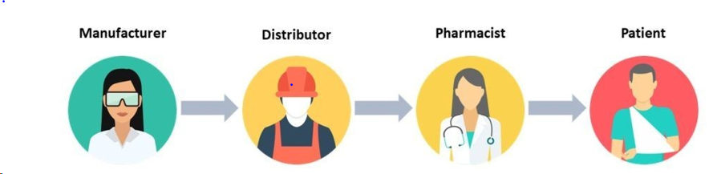

**Application**

○ **Prerequisites**

* Visual studio code
* Knowledge of Hyperledger Fabric
* Working on Linux, goLang

○ **Installation**

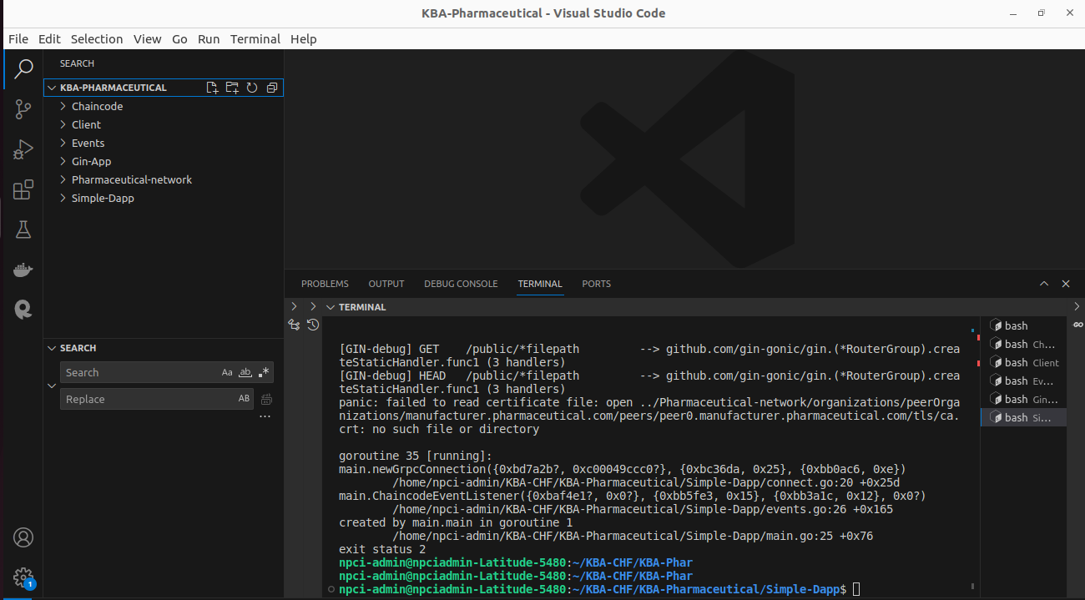

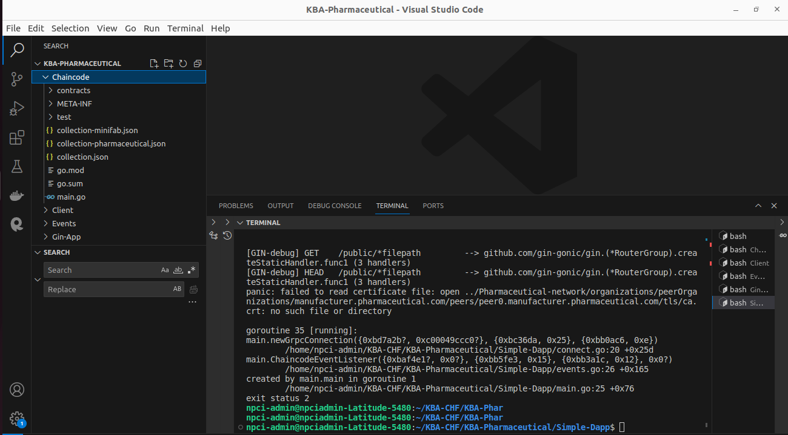

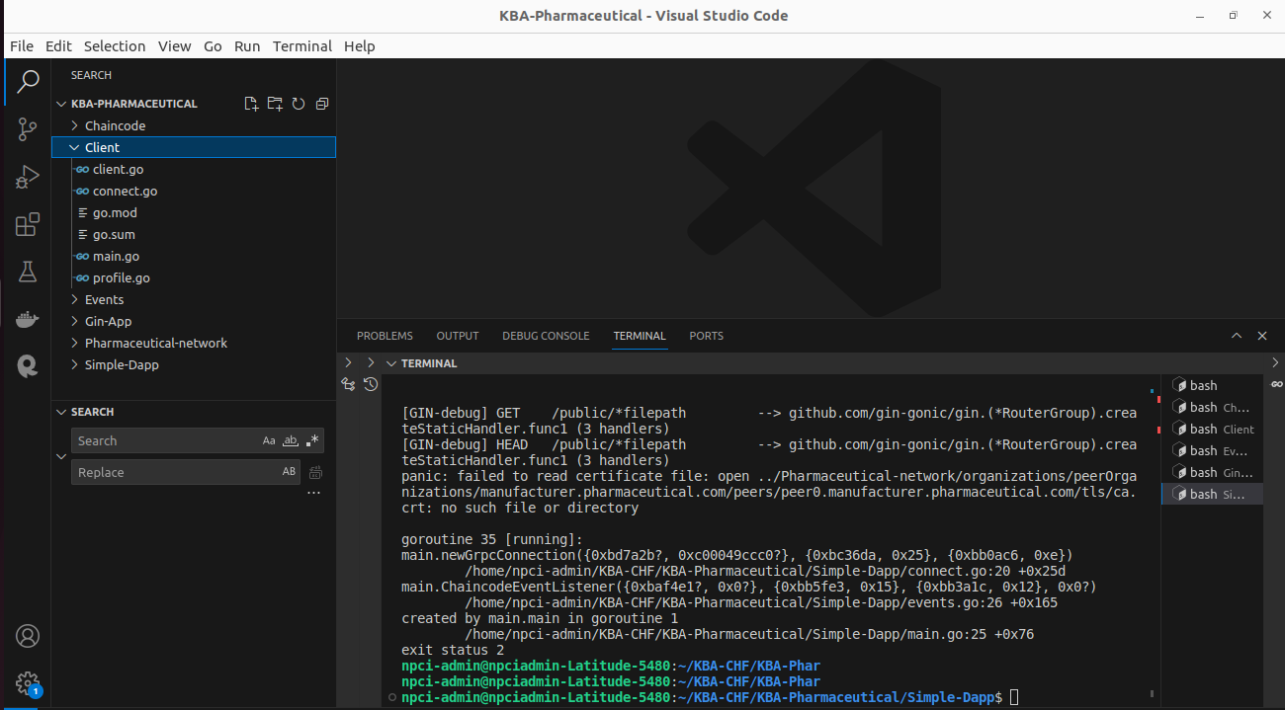

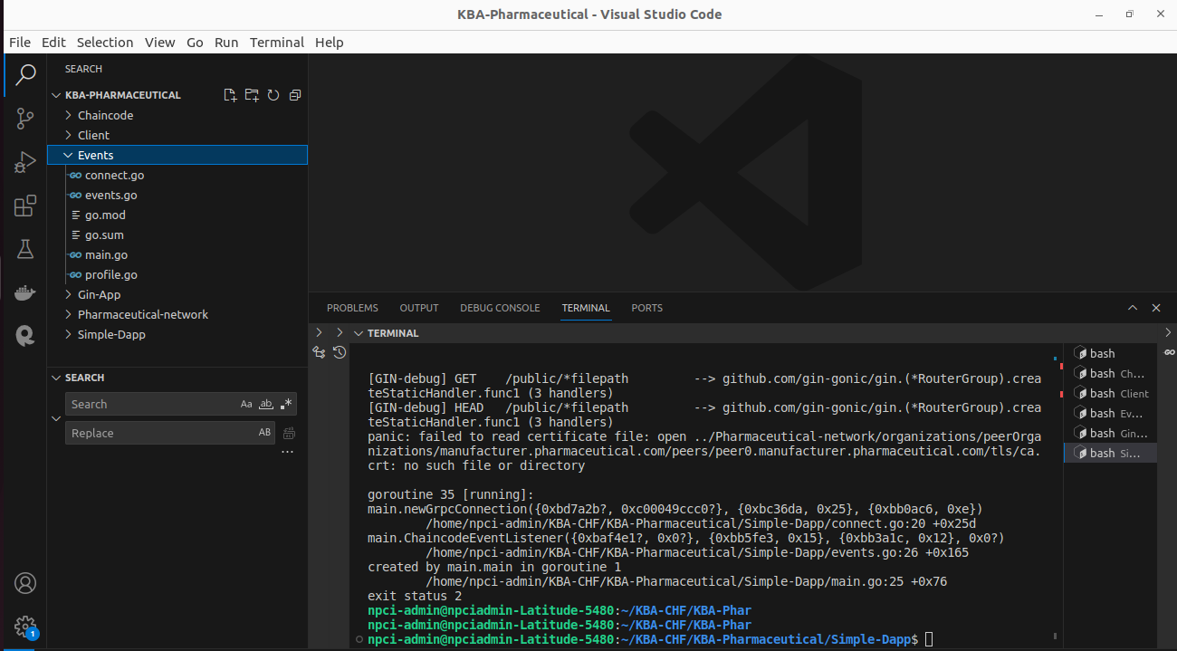

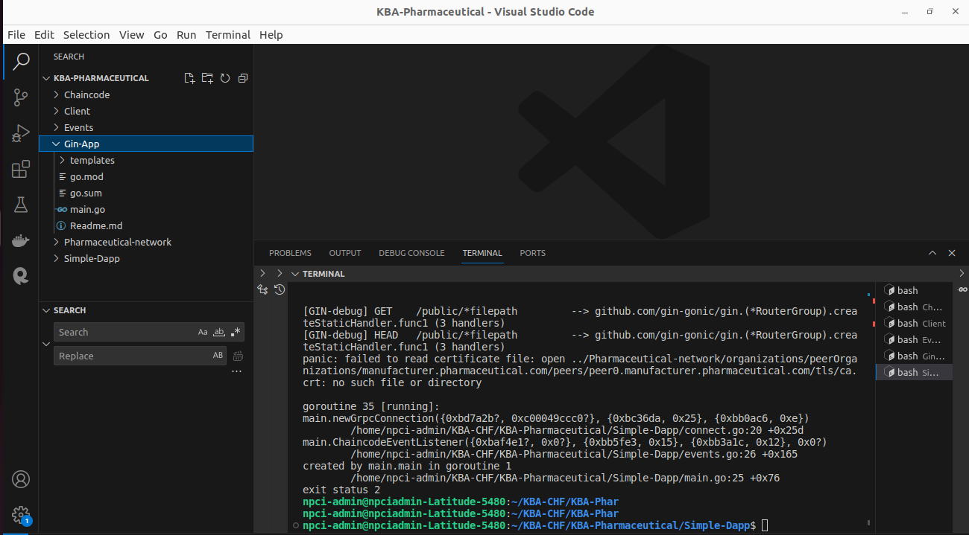

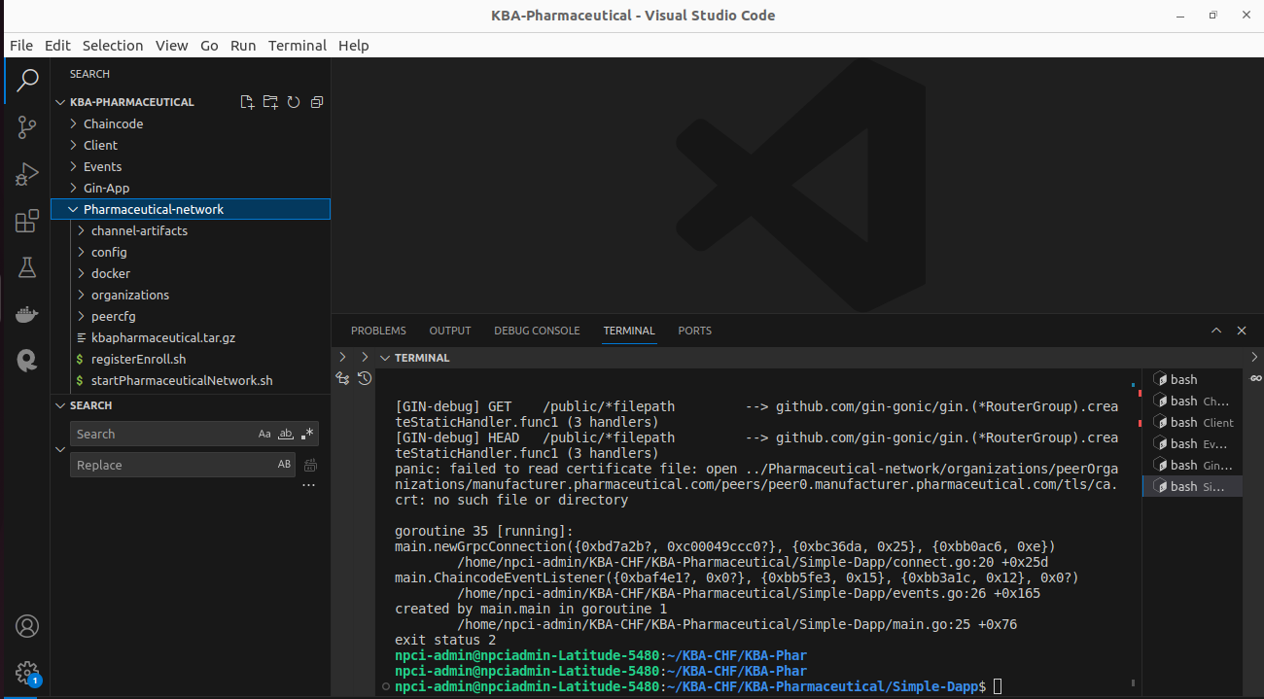

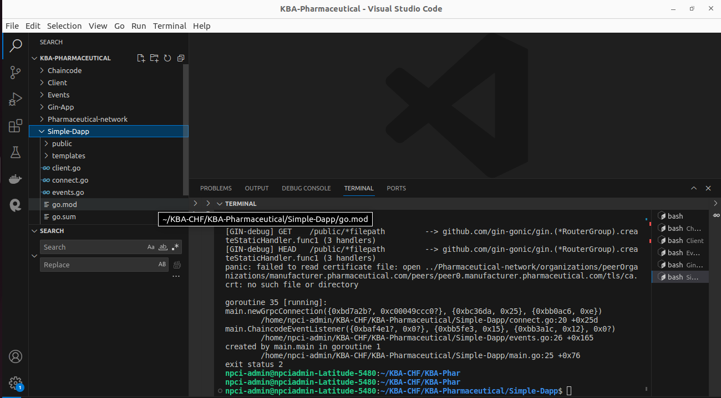

./startPharmaceuticalNetwork.sh

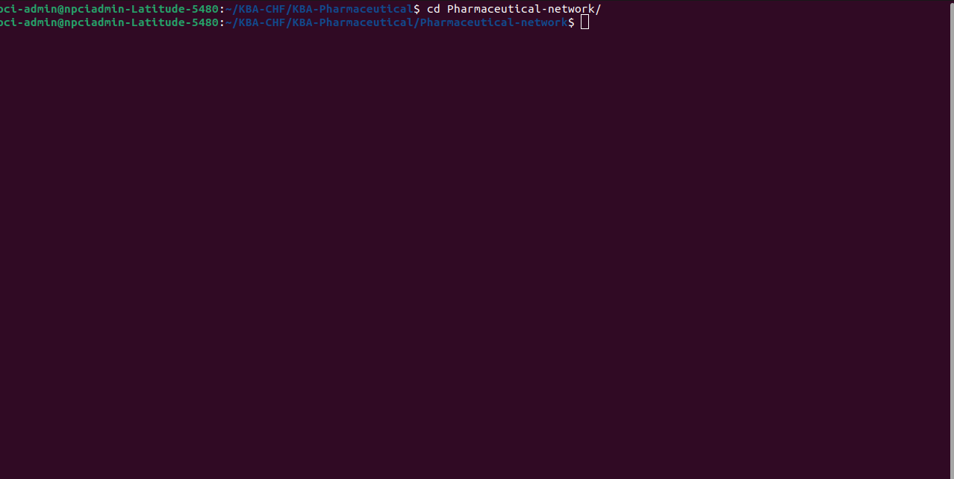

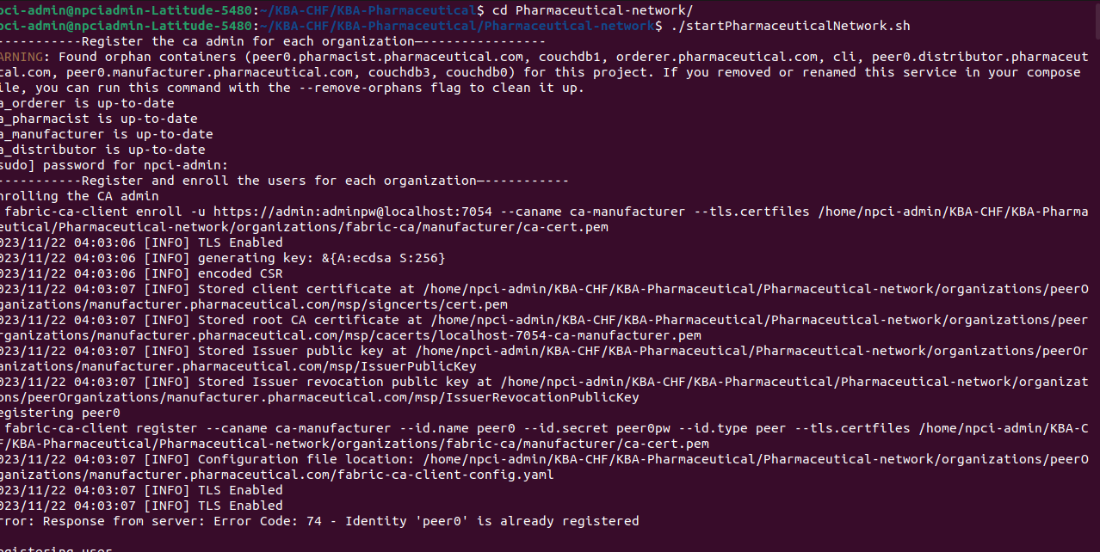

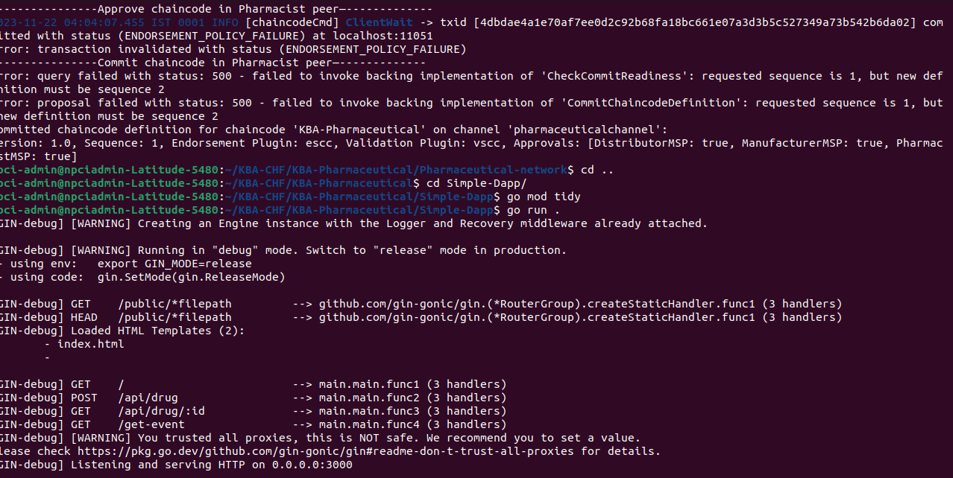

**Chaincode Functions**

* CreateProduct
* ReadProduct
* UpdateProduct
* DeleteProduct

**Resources and technologies Used**

1. Hyper ledger fabric
2. Golang
3. Shell script
4. Docker
5. CouchDB
6. Postman
7. Gitlab
8. Git

**Transaction Details:**

**1st screen with Blank fields**

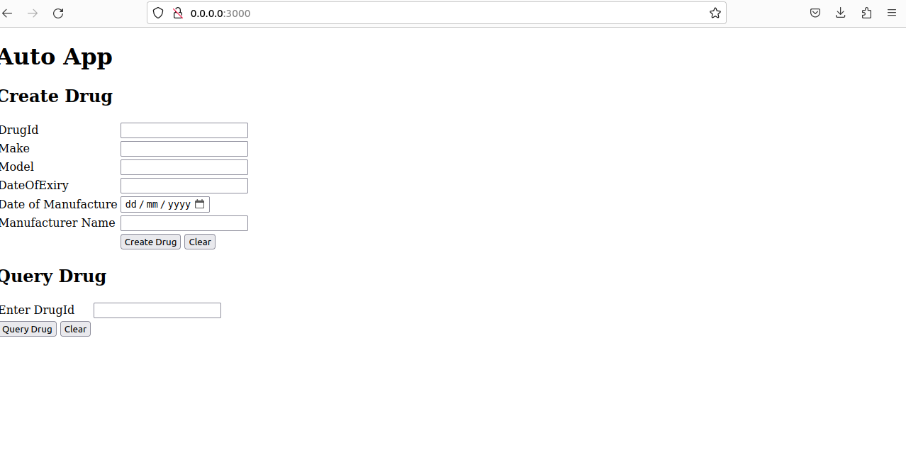

**Creating the Drug entry**

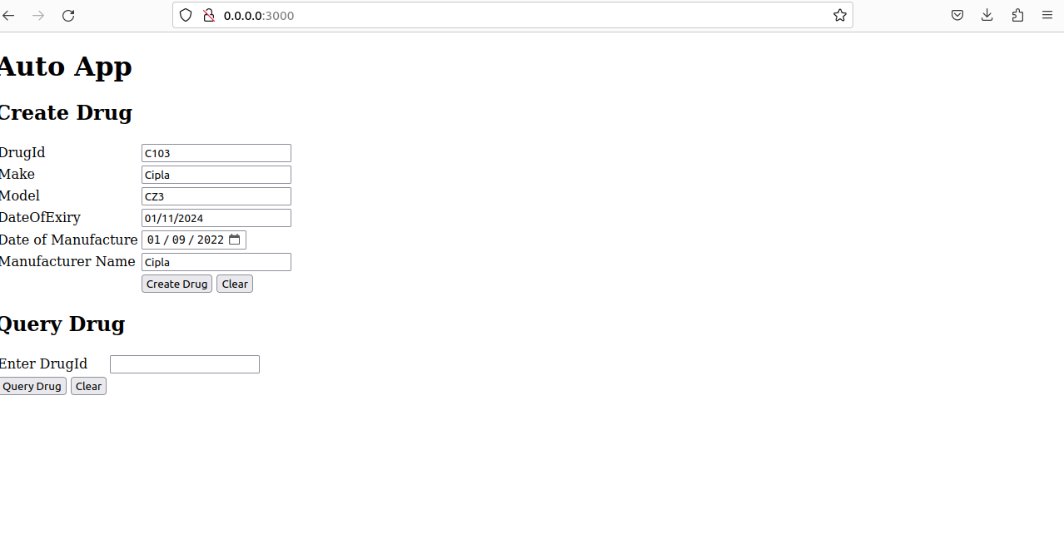

**Confirmation of the Drug Created**

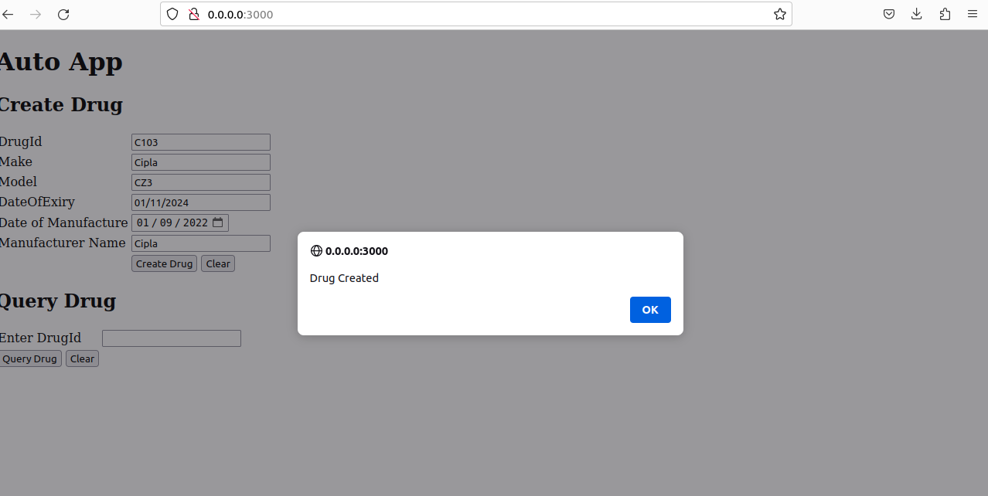

**Fetching the Drug from the Table**

